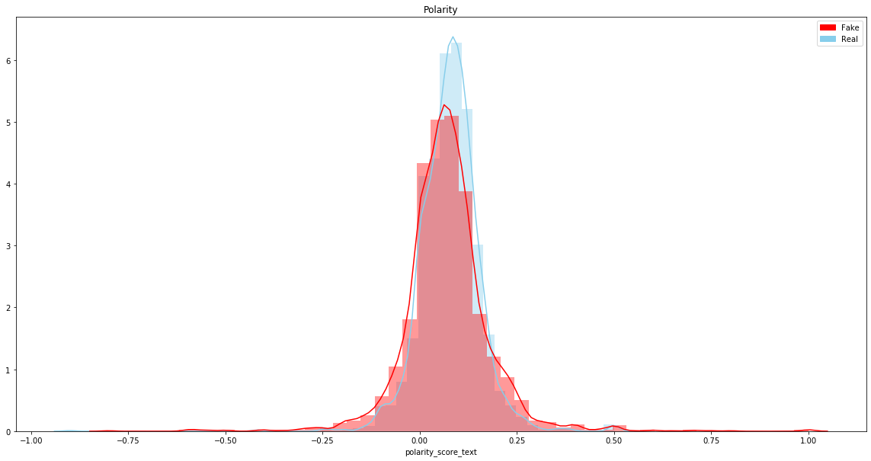

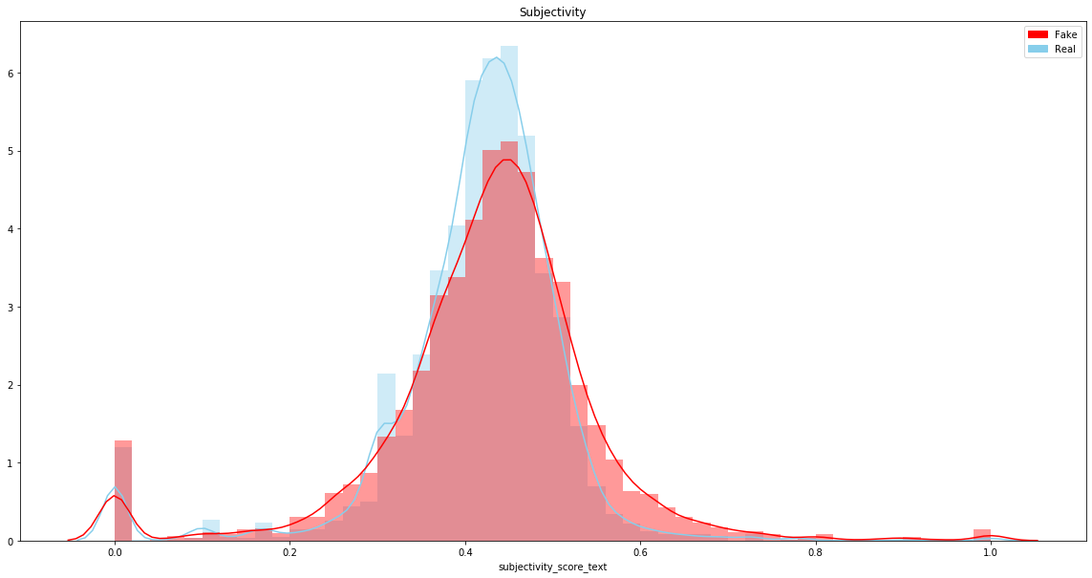

We can find that real news looks a bit more positive but the polarities of both real news and fake news averaging below 0.1. Even if both are classed as neutral, the variance of real news is obviously smaller than the fake. As the words in fake news can sometimes be exaggerated in order to gain attention from the readers or make people impressive.

In a similar manner, the exaggerations can also cause a high level of subjectivity. However, the difference between their averages is not significant. As makers of the fake news can convince readers by disguising the fake news with a content which looks objective. As quite a number of news has a subjectivity near 0, people can guess that the reporters are able to make news rather objective if they want. Therefore, it can be hard to differentiate real news and fake news merely by subjectivity.

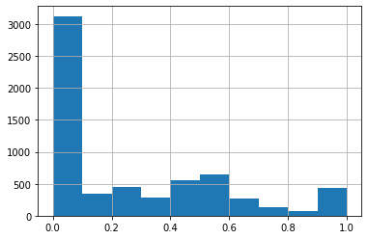

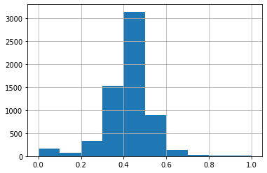

The distribution of the subjectivity of titles is totally different from that of texts. Titles are easier to be written objectively. Most of titles have a subjectivity below 0.2 while that of texts averaging more than 0.4. The titles are easier to be written objectively than texts.

Apart from most news which are shown to be neutral, the proportion of positive news is more than that of negative news. Take a look at the texts which are shown to be negative, and it is easy to find that many of them consist of the words like ‘obama’, ‘hillary clinton’, ‘donald trump’, etc. One can guess that these words are more likely to be used in fake news for some political reasons or just for fun like what The Onion often do, which may cause a larger variance of the polarity of fake news.